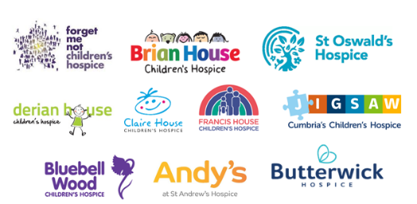


Project Brief
Data Project for the Northern Children’s Hospice Collaborative

The CEOs of 10 Children’s Hospices – the Northern Children’s Hospice Collaborative (NCHC) across the north of England are looking for an individual with data and project management experience to carry out our data alignment and improvement project.

We want to work with an individual with the right skills to support us to achieve our aims in a way which gives them the opportunity to shape the project. We are keen to hear from individuals who will relish the challenge.

What is the Northern Children’s Hospice Collaborative?
This informal collaborative of Northern Children’s Hospices is made up of:
- Andy’s – part of St Andrew’s in Grimsby
- Bluebell Wood – Sheffield
- Brian House – Blackpool
- Butterwick – Stockton-on-Tees
- Claire House – Merseyside
- Derian House – Chorley
- Forget-Me-Not – Huddersfield
- Francis House – Manchester
- Jigsaw Cumbria’s Children’s Hospice – Carlisle
- St Oswald’s – Newcastle

What is the Data Project?
The Collaborative has secured funding from The Albert Hunt Trust for a time limited data alignment and improvement project to support the hospices to be clearer about their activity and impact.
This is a strategic piece of work across a significant footprint (from Grimsby to Newcastle and Carlisle to Liverpool) and requires an approach that involves:
- Some practical data skills to support organisations to move towards a single recording, reporting and presentation of key data.
- Understanding of the strategic ambition and support the Collaborative to ensure we can show both the numbers and the ‘so what’.
- The skills to help develop and strengthen relationships.
The project will be hosted by St Oswald’s Hospice in Newcastle with an expectation that the role could be fully remote or based at any of the hospices. Travel to all sites from time to time is essential.
An awareness of issues impacting on equity of access and health inequalities is essential and understanding of the complexity of describing activity within the children’s hospice sector.

What will it entail?
      - Review the range of data that is collected across the hospices.
      - Review and learn from other areas where similar alignment work has been undertaken to ensure we learn from other areas.
      - Develop an approach where the data and language are aligned and comparable to provide a clearer picture across a larger footprint (all our ‘apples’ are ‘apples’)
      - Develop a cohesive approach to align data which will help commissioners to better understand the needs of our cohort of children and the impact of children’s hospices
      - Develop a way of sharing quantitative and qualitative data understanding the challenges and complexities and existing systems for sharing information
      - Accurately describing the gap between capacity and activity
      - Support the strengthening of collaboration across hospices across the north of England
      - Provide a strong foundation to develop further research opportunities to within the children’s hospice collaborative to adapt to the changing health and care landscape

Planned Outcome - In 18 months’ time we want a clearer picture of the activity in children’s hospices across this northern footprint (not the whole patch) and the impact that has for our NHS and wider health and care services. We want certainty that we are describing the same things in the same way and to avoid extrapolations which may undermine our argument for sustainable support.

Deadline: Midday (12pm) 12th December 2025
Interviews: w/c 12th January 2026
Budget: Up to £52,000 over a period of up to 18 months.
(The project may need more input at the start, but overall approach can be managed by the successful candidate).

Specifically, you will:
- Deliver this project on behalf of the collaborative, ensuring it is delivered on time, within budget, and evaluated against agreed outcomes.
- Operate effectively in a dynamic and flexible environment, proactively engaging
- with hospice partners to deliver the project.
- Support and work within the values and behaviours of the hospices, championing hospice philosophy while working in the collective interest of NCHC.

We look forward to receiving a short proposal from you to include:
- Your CV
- A short statement of how you would approach this work and the skills and experience you would bring to the table, including the knowledge you have of Palliative and End of Life Care, the challenges for children and families living with life limiting complex conditions, the children’s hospice sector and the wider health and care system.
- Your approach to delivering the project and experience with data and collaborating across organisations.

If you would like to have an informal conversation about this role, please contact Julie Clayton, the CEO at Jigsaw Cumbria’s Children’s Hospice at julie.clayton@edenvalleyhospice.org by the 9th December 2025 (deadline to submit your proposal is the 12th December 2025)

